COS20019
Cloud Computing Architechture
Truong Ngoc Gia Hieu
105565520
Week 9 – ACA Module 14
Challenge Lab: Implemeting a Serverless Architecture for the Café
Challenge Lab: Implementing a Serverless Architecture for the Café

Scenario

The café's business is thriving. Frank and Martha want to get daily sales reports for products that are sold from the café's website. They will use this report to plan ingredient orders and monitor the impact of product promotions.

Sofía and Nikhil's initial idea is to use one of the Amazon Elastic Compute Cloud (Amazon EC2) web server instances to generate the report. Sofía sets up a cron job on the web server instance, which sends email messages that report daily sales. However, the cron job reduces the performance of the web server because it's resource intensive.

Nikhil mentions the cron job and how it reduces the web application's performance to Olivia. Olivia advises Sofía and Nikhil to separate non-business-critical reporting tasks from the production web server instance. After Sofía and Nikhil review the advantages and disadvantages of their current approach, they decide that they don't want to slow down the web server. They also consider running a separate EC2 instance, but they are concerned about the cost of running an instance 24/7 when it's only needed for a short time each day.

Sofía and Nikhil decide that running the report generation code as an AWS Lambda function would work, and it would also lower costs. The report itself could be sent to Frank and Martha's email address through Amazon Simple Notification Service (Amazon SNS).
In this lab, you take on the role of Sofía to implement the daily report code as a Lambda function.

A. Lab overview and objectives

In this lab, you use AWS Lambda to create a café sales report that's emailed each day through Amazon SNS.

After completing this lab, you should be able to implement a serverless architecture to generate a daily sales report that features the following:
- A Lambda function within a virtual private cloud (VPC) that connects to an Amazon Relational Database Service (Amazon RDS) database with the café's sales data
- A Lambda function that generates and runs the sales report
- A scheduled event that initiates the sales report Lambda function each day

When you start the lab, your architecture looks like the following example:
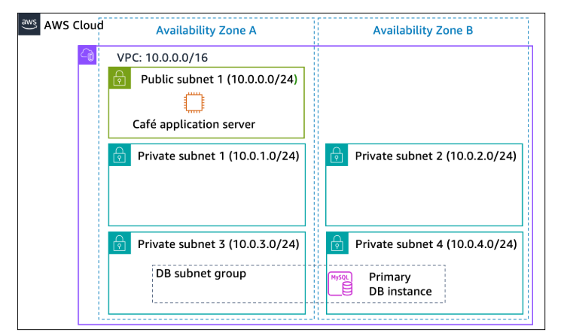
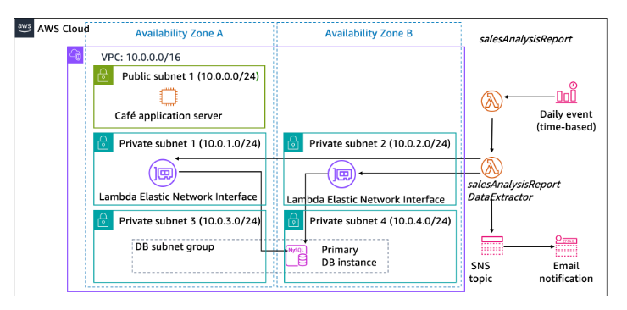
At the end of this lab, your architecture will look like the following example:

Duration
This lab requires approximately 90 minutes to complete.

AWS service restrictions
In this lab environment, access to AWS services and service actions might be restricted to the ones that are needed to complete the lab instructions. You might encounter errors if you attempt to access other services or perform actions beyond the ones that are described in this lab.

B. Accessing AWS Management Console
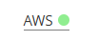

Figure 1: AWS Activated

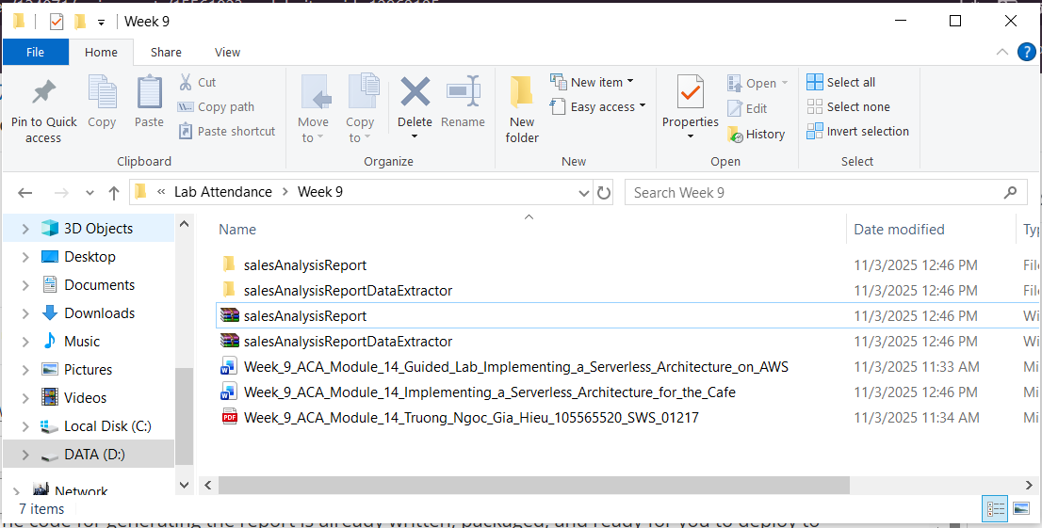
C. Task 1: Downloading the source code
Figure 2: Materials downloaded

D. Task 2: Creating the DataExtractor Lambda function in the VPC
In this task, you create the DataExtractor Lambda function that extracts the café's sales data from an Amazon RDS database. So the Lambda function can access the RDS database instance, you must update the database security group with a rule to allow connections from the Lambda function. To enable this communication, you create a security group for the Lambda function and add it as an inbound rule to the security group of the RDS instance.

Step 2.1: Search and select EC2 service. Then, create security group with following configurations:
- Security group name: LambdaSG
- VPC: Lab VPC
- Outbound Rules: All traffic to all addresses
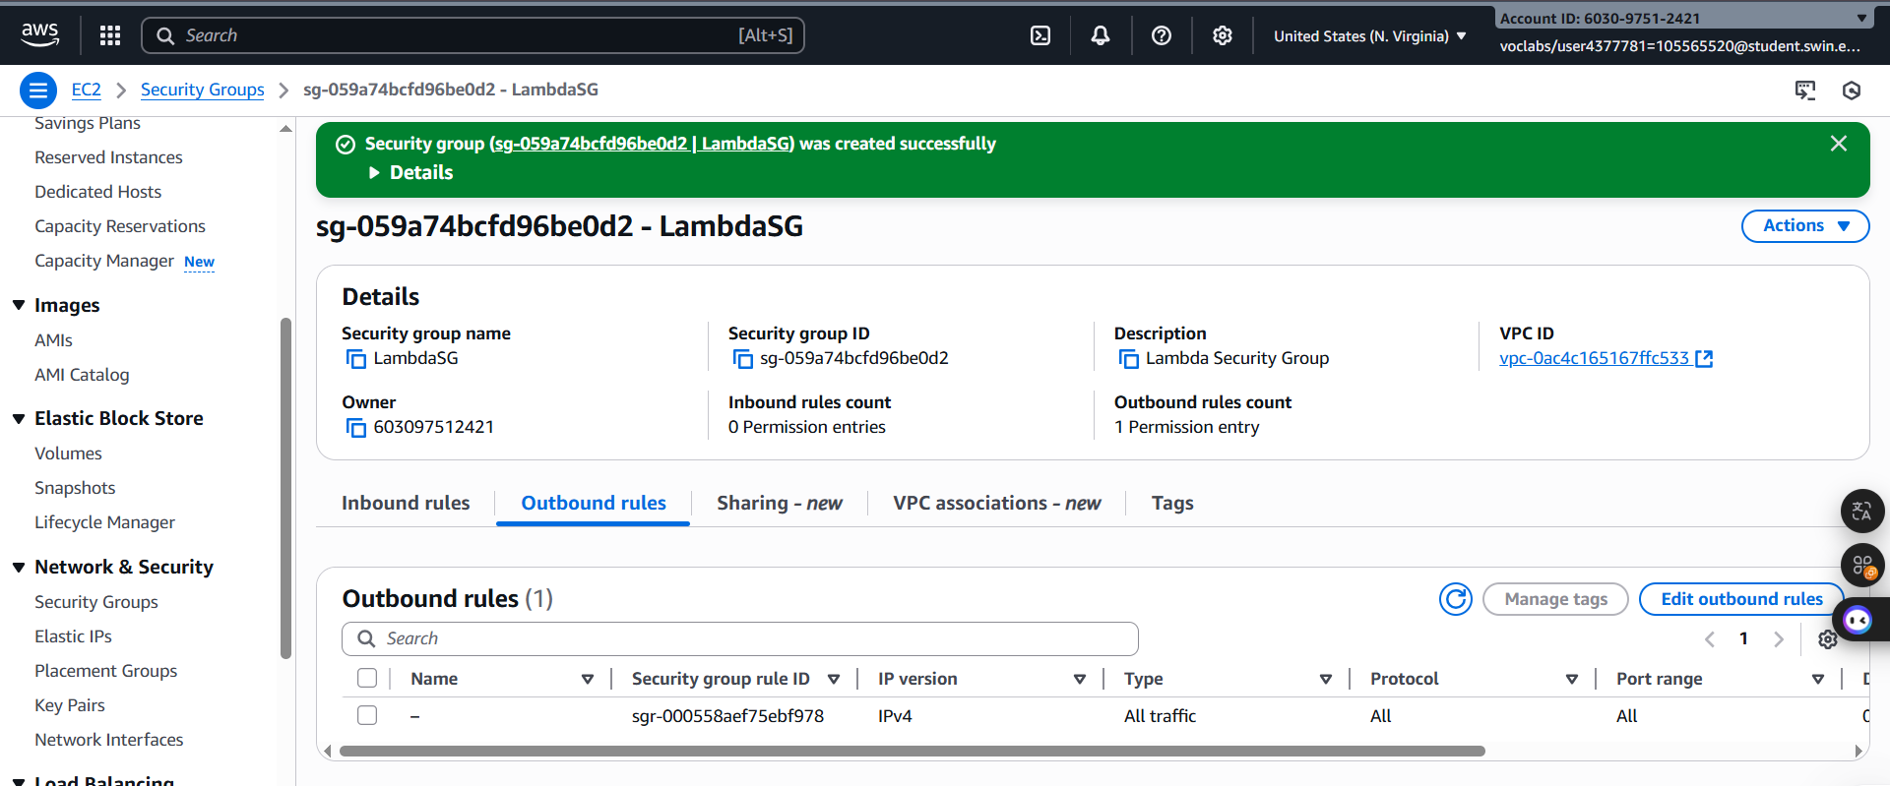
Figure 3: LambdaSG

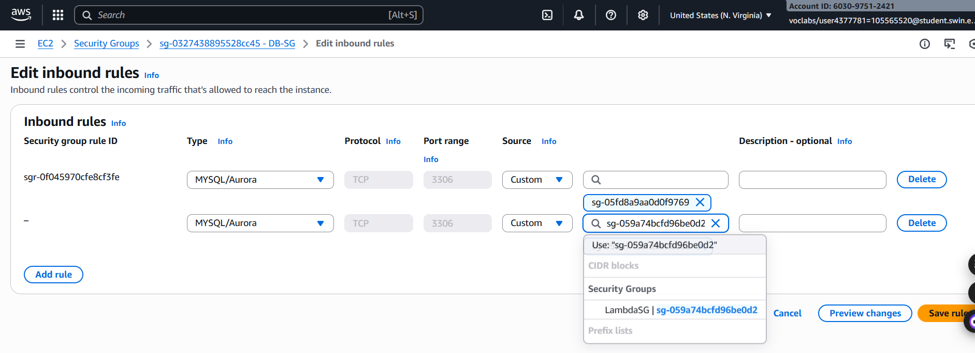
Step 2.2: Update the DatabaseSG security group.

Figure 4: Inbound rule configuration

Step 2.3: Create a Lambda function with the following settings:
- Function name: salesAnalysisReportDataExtractor
- Runtime: Python 3.11
- Role: salesAnalysisReportDERole
- VPC:
- VPC: Lab VPC
- Subnets: Private subnet 1 and Private subnet 2
- Security Group: The Lambda function security group that you created
Tip: It will take several minutes for the function to be created.

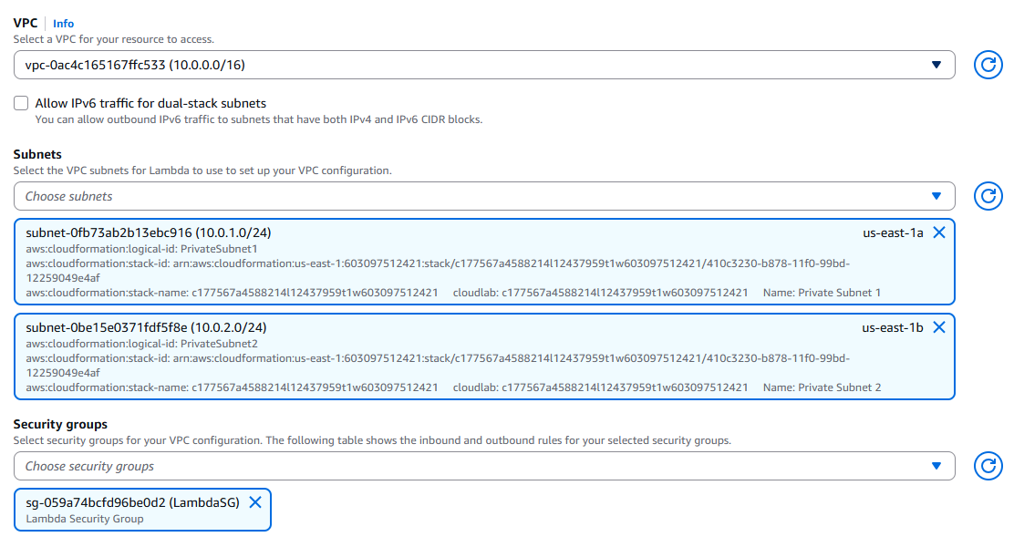
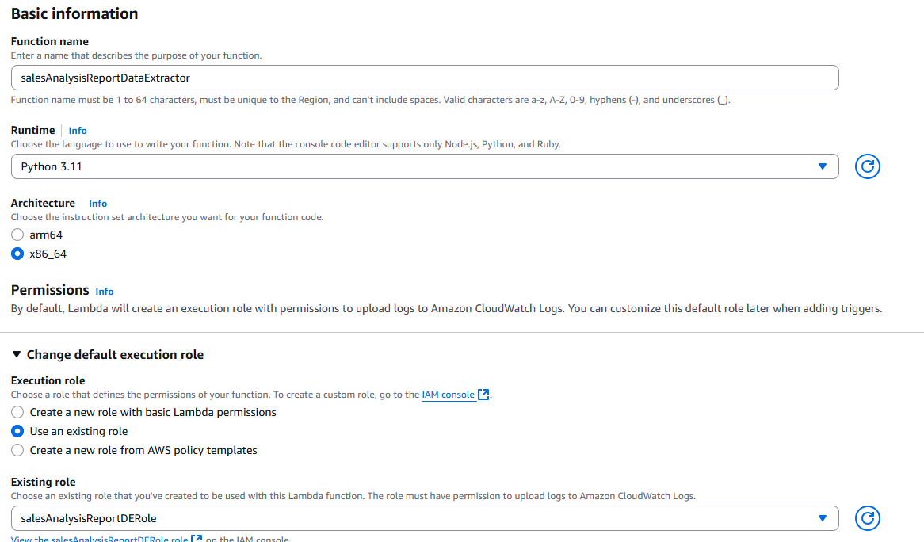
Figure 5: Basic Information configuration
Figure 6: Additional configuration
Step 2.4: Configure the DataExtractor Lambda function as follows:
- Code: Upload the salesAnalysisReportDataExtractor.zip file
- Description: Lambda function to extract data from database
- Handler: salesAnalysisReportDataExtractor.lambda_handler
- Memory Size: 128 MB
- Timeout (seconds): 30

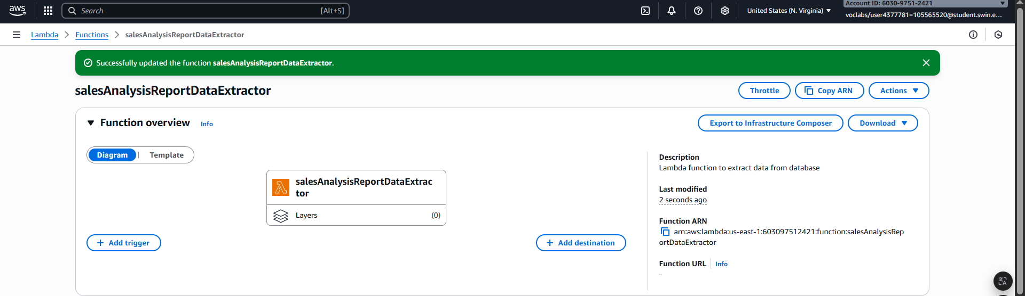
Figure 7: Configuration completed
E. Task 3: Creating the SalesAnalysisReport Lambda function
In this task, you create the Lambda function that generates and sends the daily sales analysis report.

Step 3.1: Create a second Lambda function with the following settings:
- Function name: salesAnalysisReport
- Runtime: Python 3.11
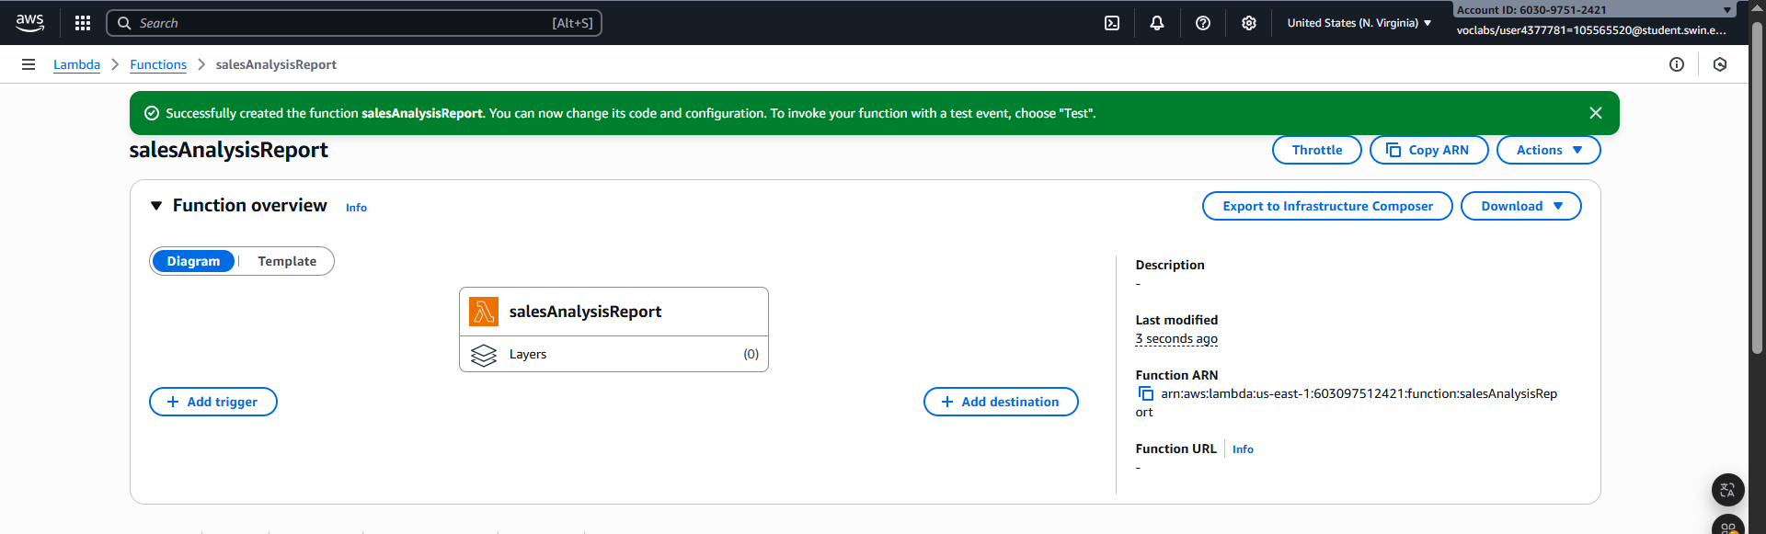
- Role: salesAnalysisReportRole
Figure 8: Function created successfully

Step 3.2: Configure the salesAnalysisReport Lambda function as follows:
- Code: Upload the salesAnalysisReport.zip file
- Description: Lambda function to generate and send the daily sales report
- Handler: salesAnalysisReport.lambda_handler
- Memory Size: 128 MB
- Timeout (seconds): 30
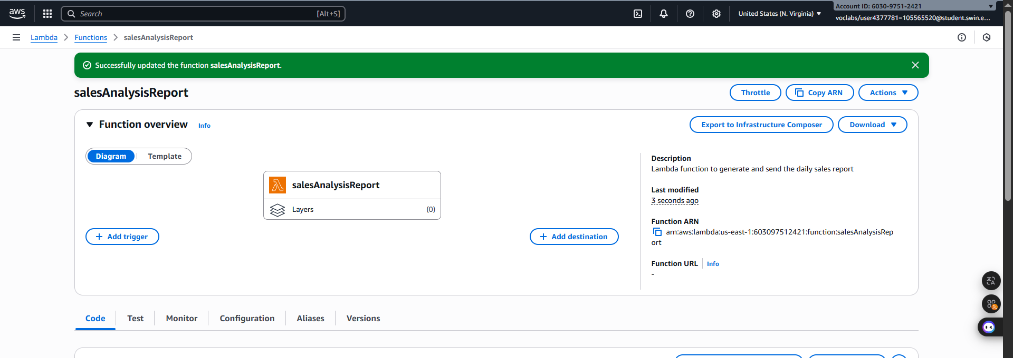
Figure 9: Configuration completed

F. Task 4: Creating an SNS topic
The sales analysis report uses an SNS topic to send the report to email subscribers. In this task, you create an SNS topic and update the environment variables of the salesAnalysisReport Lambda function to store the topic Amazon Resource Name (ARN).

Step 4.1: Create a standard SNS topic with the following configuration:
- Name: SalesReportTopic
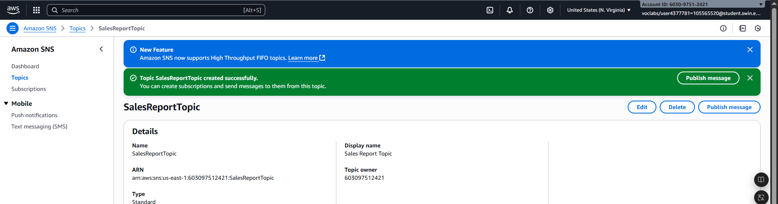
- Display Name: Sales Report Topic
Figure 10: SalesReportTopic created successfully

Step 4.2: Update the salesAnalysisReport Lambda function by adding the following environment variable:
- Variable Name: topicARN
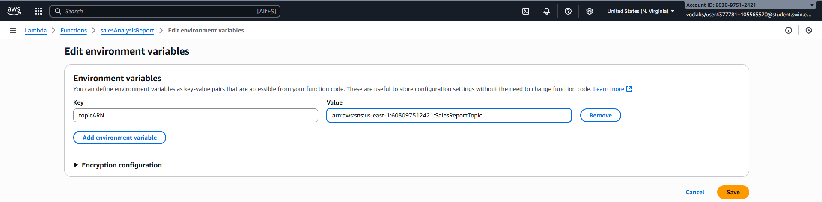
- Variable Value: The ARN of the topic you just created
Figure 11: Variable configuration

G. Task 5: Creating an email subscription to the SNS topic
To receive the sales report through email, you must create an email subscription to the topic that you created in the previous task.

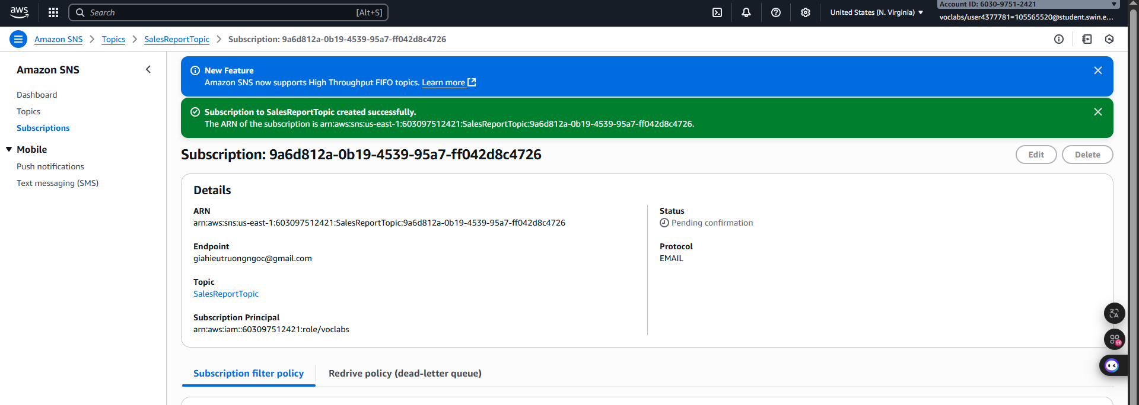
Step 5.1: Create a new email subscription to the topic. Use an email address that you can easily access for this lab.
Figure 12: Subscription configured successfully

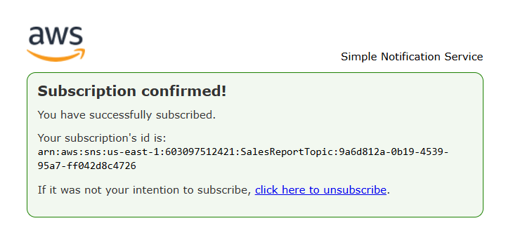
Step 5.2: Confirm the email subscription from your email client. Note: If you don't receive an email confirmation, check your Junk or Spam folder.
Figure 13: Subscription confirmed

H. Task 6: Testing the salesAnalysisReport Lambda function
Before creating the daily reporting event, you must test that the salesAnalysisReport Lambda function works correctly.

Step 6.1: Create a test for the salesAnalysisReport Lambda function.

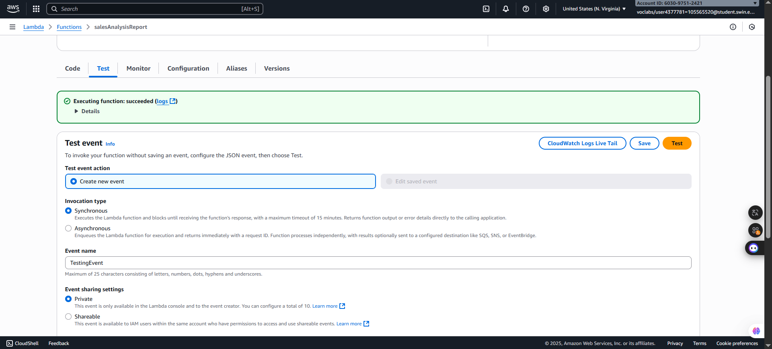
Step 6.2: Run the salesAnalysisReport test. If the test succeeds, you should have an email report in a couple of minutes.
Figure 14: Test success

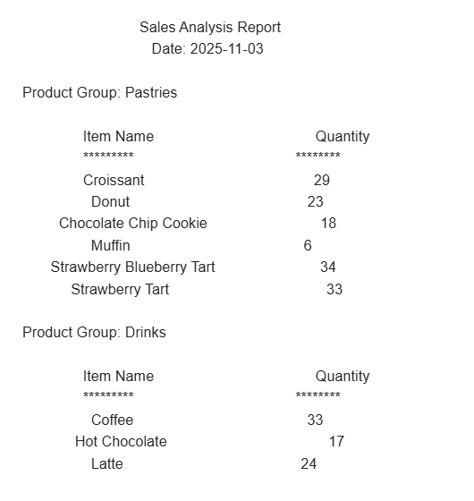

Figure 15: Sales Anaysis Report

I. Task 7: Setting up an Amazon EventBridge event to initiate the Lambda function each day
The last step in this challenge is to set up an event to run the report each day.
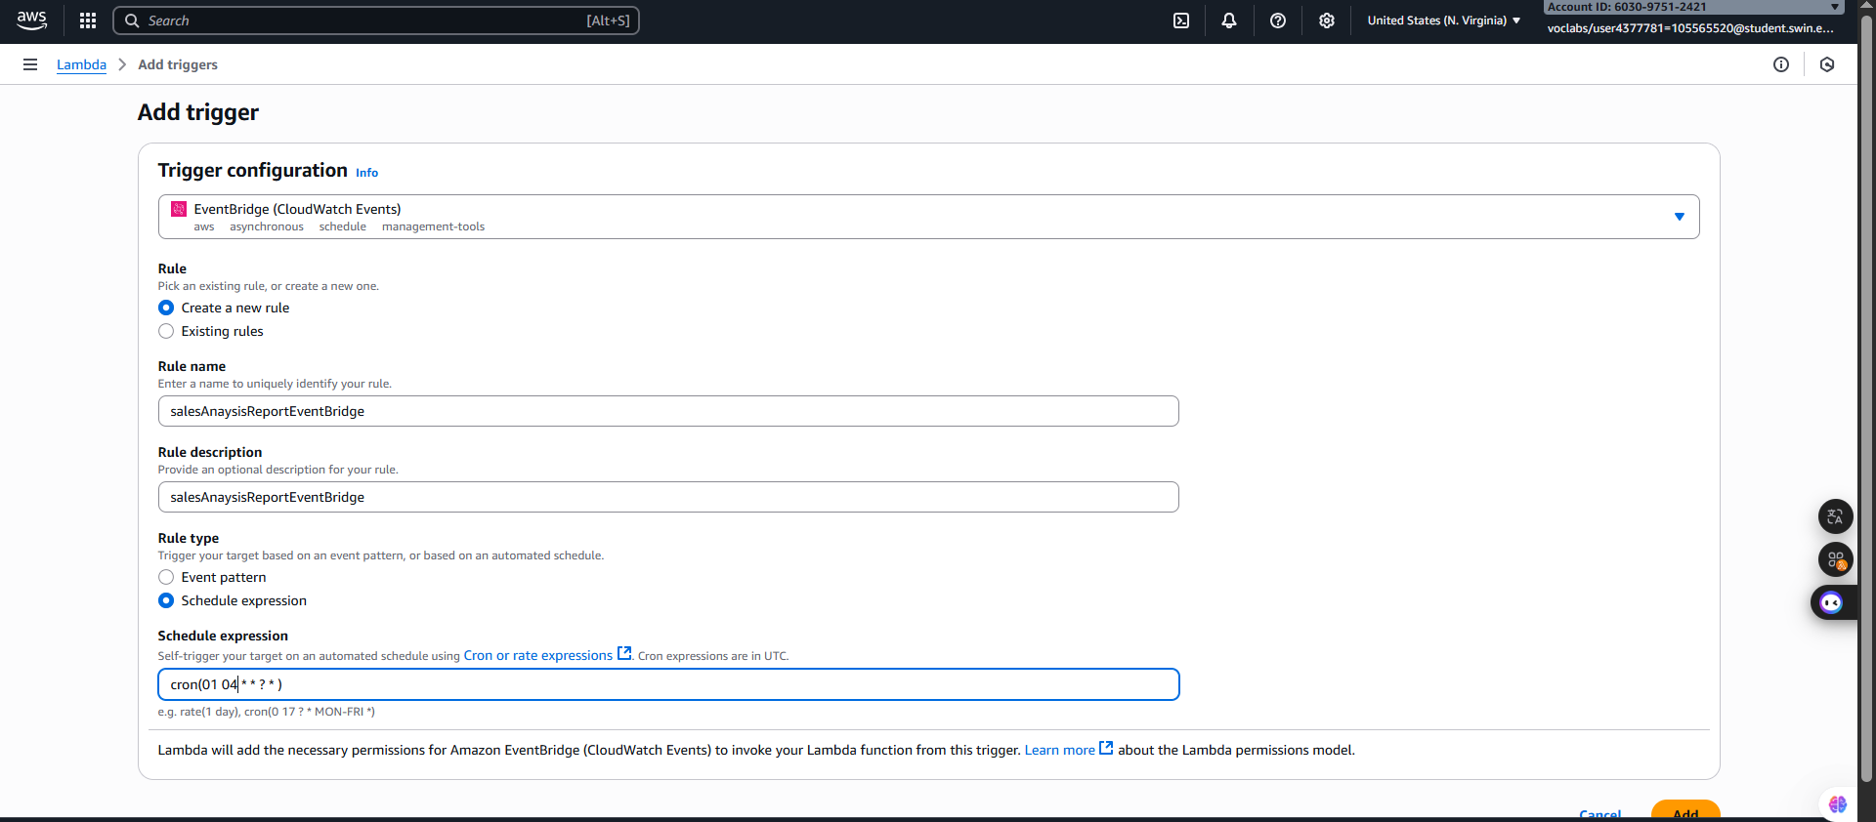
Step 7.1: Create a new EventBridge rule that runs the salesAnalysisReport Lambda function each day at a specific time. Make sure to choose Continue to create rule.
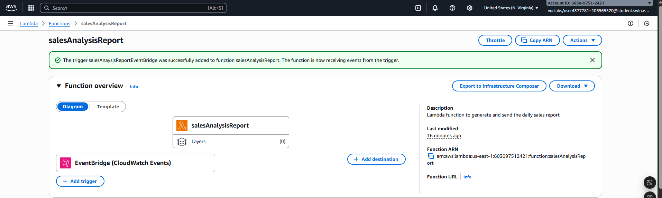
Figure 16: Trigger configuration

Figure 17: Add trigger successfully

J. Questions

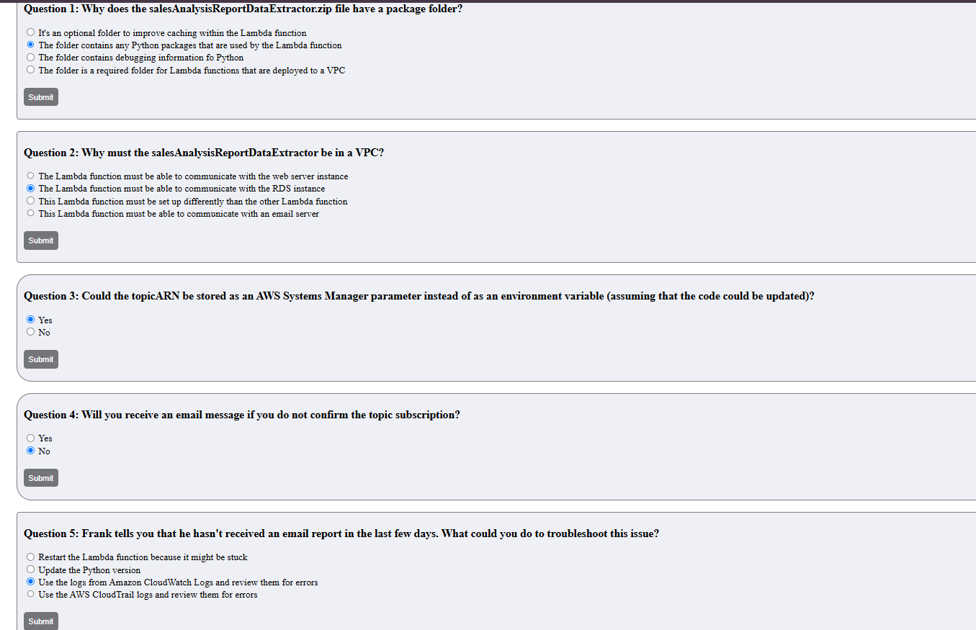
Figure 18: Questions

K. Task Completed
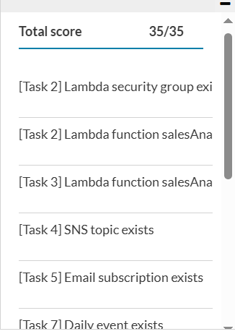

Figure 19: Task Completed

L. Conclusion
This challenge successfully addressed the performance limitations of generating resource-intensive daily sales reports directly on the production web server's EC2 instance. The initial reliance on a local cron job negatively impacted application performance and was not cost-optimized for a once-a-day task.

To resolve this, a modern, cost-effective serverless architecture was implemented utilizing AWS services. The core solution involved decoupling the task and using AWS Lambda (for secure RDS data extraction and report formatting), Amazon SNS (for reliable email distribution via the SalesReportTopic), and Amazon EventBridge (to schedule the daily report generation automatically).

By leveraging AWS Lambda, the solution successfully transitioned a business-critical yet resource-heavy task to a fully managed, pay-per-use environment, significantly reducing operational costs compared to running a dedicated EC2 instance 24/7. This implementation improves the overall performance and stability of the main café application while ensuring Frank and Martha receive their sales analysis reports reliably each morning.

